Project Enhancements Guide

Contents

What is Odoo Project? 2

What is Odoo Project Enhancements? 2

Administrator Configuration 3

Project Enhancement App Setup 3

Task Logs (Timesheets) 3

Enabling Time Logs for Tasks 3

Forecasting 4

Enabling Forecasting 4

Forecast Settings 4

Sub-Tasks 5

Enabling Sub-Tasks 5

Project Statuses 5

Creating/Editing Project Statuses 5

Project Types 6

Creating/Editing Project Statuses 6

Use Rating on Project 6

Collaborative Pads 7

Creating a new project (Not from Template) 7

Manage your project's stages 8

Add your project's stages 8

Rearrange stages 9

Creating a Task 10

Responsibilities 10

Followers 10

Project: follow a project throughout the process 10

Task: follow a specific task 10

Choose which action to follow 10

Auto Forecasting 11

Enabling Auto Forecasting 11

Viewing Forecasts 12

Forecast Menu 12

On Projects 12

On Tasks 13

Milestones 14

Enabling Milestones on a Project 14

Creating Milestones 14

View by Milestones 15

Templates 17

Creating a Project Template 17

Create a new project (from Template) 17

Date Shifting 19

Enabling Date Shifting 19

Scrum 20

Enabling Scrum 20

Configuration 20

Scrum Teams 21

Issue Types 21

Labels 21

Categories 22

Sources 22

Story Points 22

Epics 22

Project Tasks (With Scrum) 23

Sprints 24

Activating/Closing Sprints 26

Releases 26

Releasing 27

# What is Odoo Project?

Odoo Project allows you to manage a project together with your whole team, and to communicate with any member for each project and task.

# What is Odoo Project Enhancements?

Odoo Project Enhancements expands the Odoo Project App and adds new enhancements including Project Templates, Milestones, Scrum, Task Date Shifting and Auto Forecasting options.

# Administrator Configuration

Some configurations are global settings, meaning they will affect all Projects. It’s important to set these global settings before creating Projects or using the Project Enhancements App. Each Project has their own settings that apply to the individual Project.

## Project Enhancement App Setup

The Project Enhancement App is accompanied by several additional modules for Templates, Scrum, Milestones and Task Date Shifting. Each can be installed independently, but all need the main Project Enhancement module. Once the main module is installed, in **Settings**/**General** **Settings** you can install/uninstall the add-on modules.

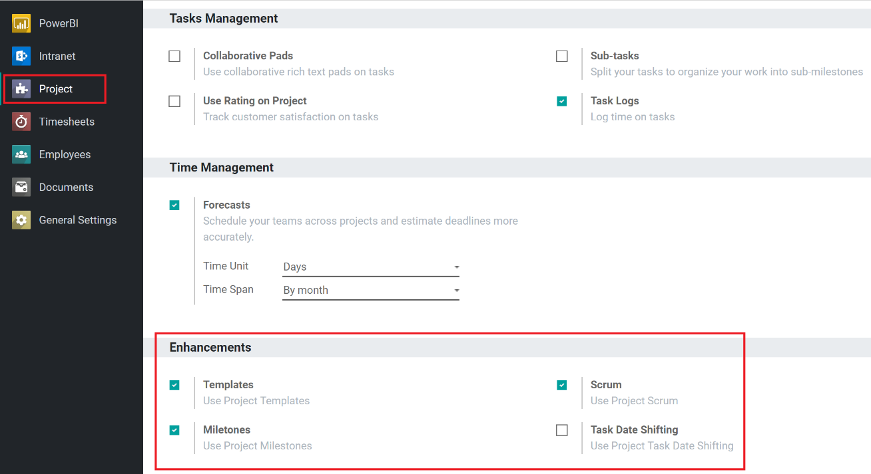

## Task Logs (Timesheets)

Task Logs allow for time management for Project Tasks. It adds a new tab on the Task form and allows users to enter Time Entries. Time Entries can then be used for billing purposes and allow for Forecasting to be used.

### Enabling Time Logs for Tasks

Enabling Time Logs enables will provide the option to use Timesheets on each Project. Only Admins can change this Global setting but once enabled, Project Managers can enable Timesheets on each Project independently.

1. Go to **Configuration/Settings.**

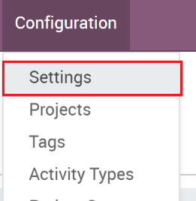

1. The ‘App Settings’ and it should auto select ‘Project’ on the left. Check the ‘**Task Logs**’ checkbox and click **Save.**

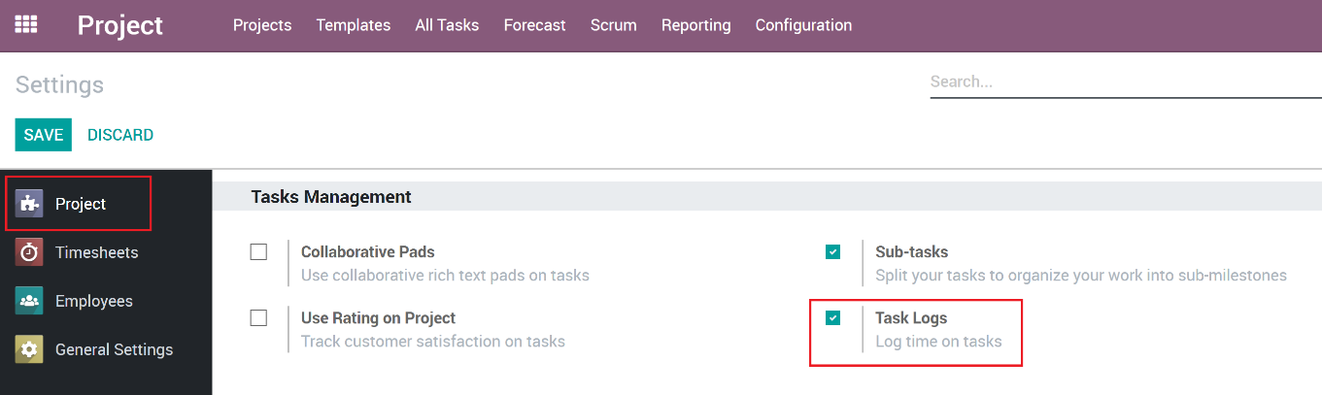

## Forecasting

Scheduling and forecasting tasks is another way to manage projects. In Odoo, the Forecast option gives you access to the Gantt chart. With the Forecast option, you can schedule/forecast other users who will be working your project tasks and the Gantt view gives you the big picture. It's highly visual which is a real plus for complex projects, and it helps team members to collaborate better

### Enabling Forecasting

Enabling Forecasts enables will provide the option to use Forecasts on each Project. Only Admins can change this Global setting but once enabled, Project Managers can enable Forecasts on each Project independently.

1. Go to **Configuration/Settings.**

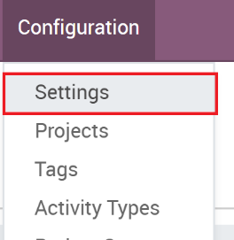

1. In the App’s list on the left, it should auto select ‘Project’. Check the ‘**Forecasts**’ Box

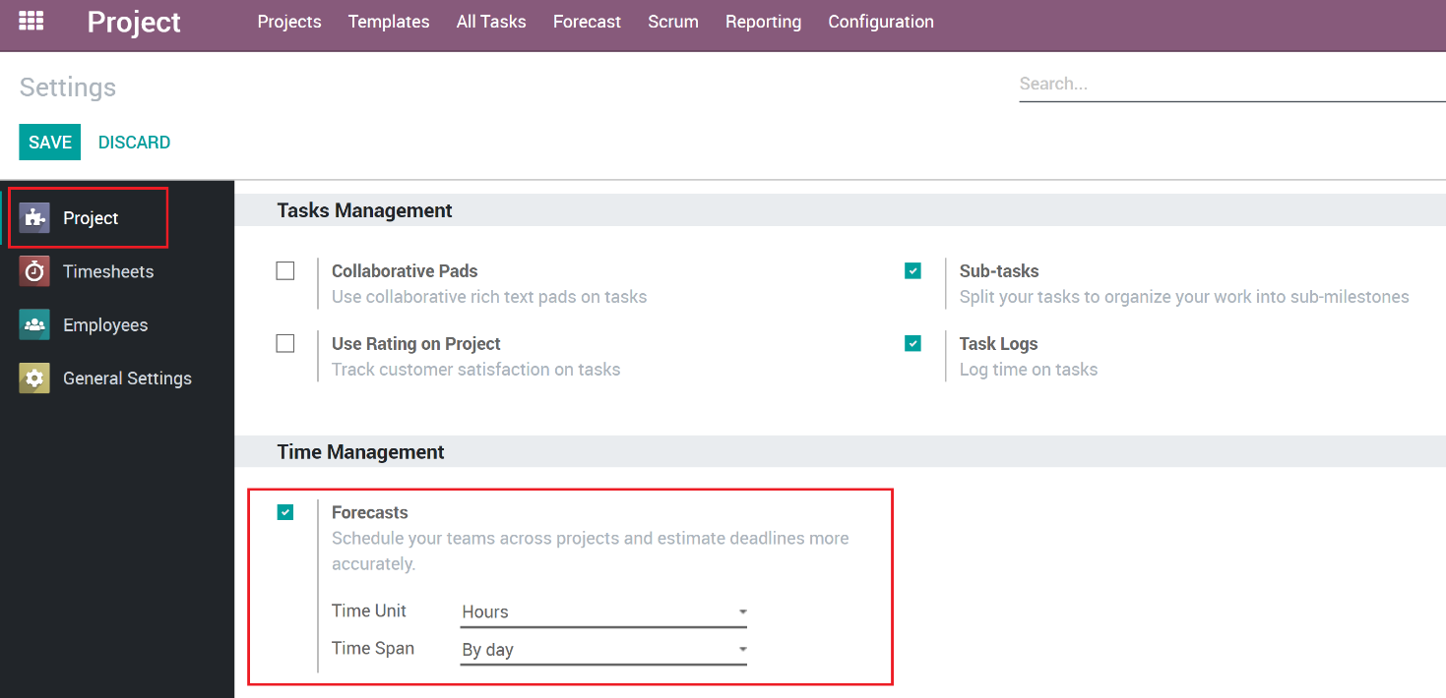

### Forecast Settings

Some additional settings are available once you enable Forecasts:

**Time Units (hours, days):** Specifies what time units will be used when creating Forecasts.

**Time Span (by day, by week, by year):** Specifies what time span will be used when looking at Forecasts on the Gantt Chart.

## Sub-Tasks

Sub-Tasks provide a way to link smaller Tasks to a parent Task. Enabling Sub-Tasks will add the ability to create sub-tasks on another Task. These Sub-Tasks are the same as a Project Task but will have a Parent Task assigned.

### Enabling Sub-Tasks

1. Go to **Configuration/Settings.**



1. In the App’s list on the left, it should auto select ‘Project’. Check the ‘**Sub-Tasks**’ checkbox and click **Save.**

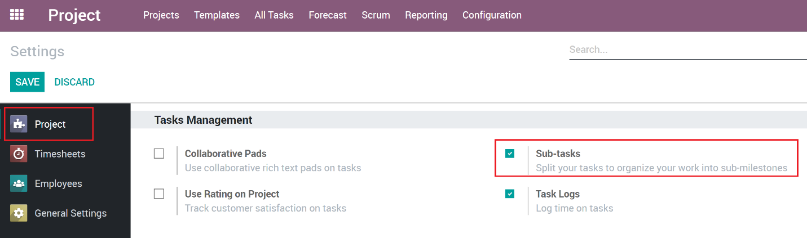

## Project Statuses

Project Statuses gives the users the ability to set and organize Project to defined statuses. Some sample statuses could be ‘Pending’, ‘In Progress’ and ‘Complete’. Project Statuses are a global configuration meaning all Projects will use the defined statuses. Note that each Project will have its own Task Statuses.

### Creating/Editing Project Statuses

Project Statuses are configured using the Configuration Menu.

1. Go to **Configuration/Statuses**

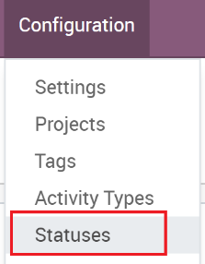

1. Click the ‘**Create’** button to create a new Status

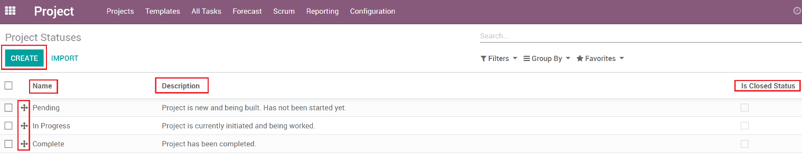

1. Enter a proper name and use the description field to provide the users an explanation for the usage of each status.
2. To re-order the list of statuses, enter debug mode and then you can drag the items in the list to re-order them.
3. Some filters use the ‘Is Closed Status’ field to no show Projects that are in a closed status. This is useful for a ‘Completed’ or ‘Canceled’ status.

## Project Types

Projects can be organized into Project Types. This is useful for when a company has many different types of projects that different departments manage.

### Creating/Editing Project Statuses

Project Statuses are configured using the Configuration Menu.

1. Go to **Configuration/Types**

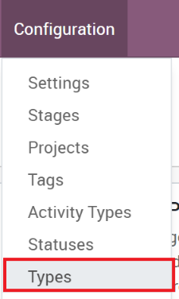

1. Click the ‘**Create’** button to create a new Type

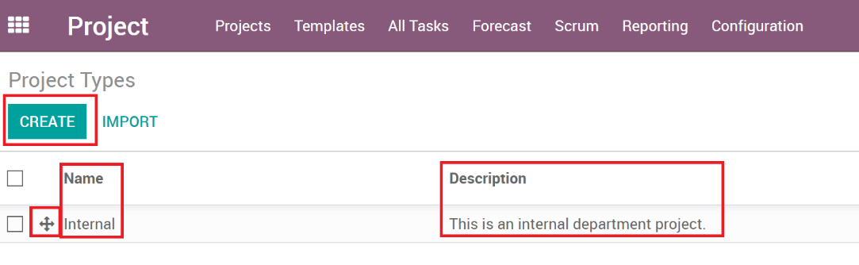

1. Enter a proper name and use the description field to provide the users an explanation for the usage of each type.
2. To re-order the list of types, enter debug mode and then you can drag the items in the list to re-order them.

## Use Rating on Project

If it’s desired to receive ratings from customers throughout the project, this can be enabled to do so. This has a global configuration to enable it and can be enabled on a per Project basis. Then each Task Stage for the Project will need to be setup to send an email when the Task moves to that stage. The built-in email template is basic and shows three faces in which the end user will click to submit their feedback.

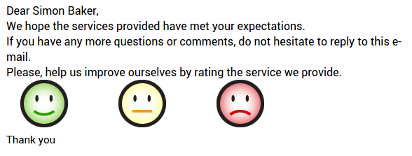

The feedback functions are simple. If desired, the survey app might be a better option, and automated actions can be an option for those to be sent, perhaps when the project status changes.

## Collaborative Pads

Odoo allows for integration with Etherpad, an online open source project to allow for collaborative editing. If setup, use the Etherpad integration to collaborate on tasks in real time with several users contributing to the same content. See etherpad.org for more information. Note: This will not be implemented for Pavlov Media at this time.

# Creating a new project (Not from Template)

You can create a project from scratch by following this procedure. See “Create a new project (from Template)” to create a Project from an existing Template.

1. Open the Project application and click on **Create**.

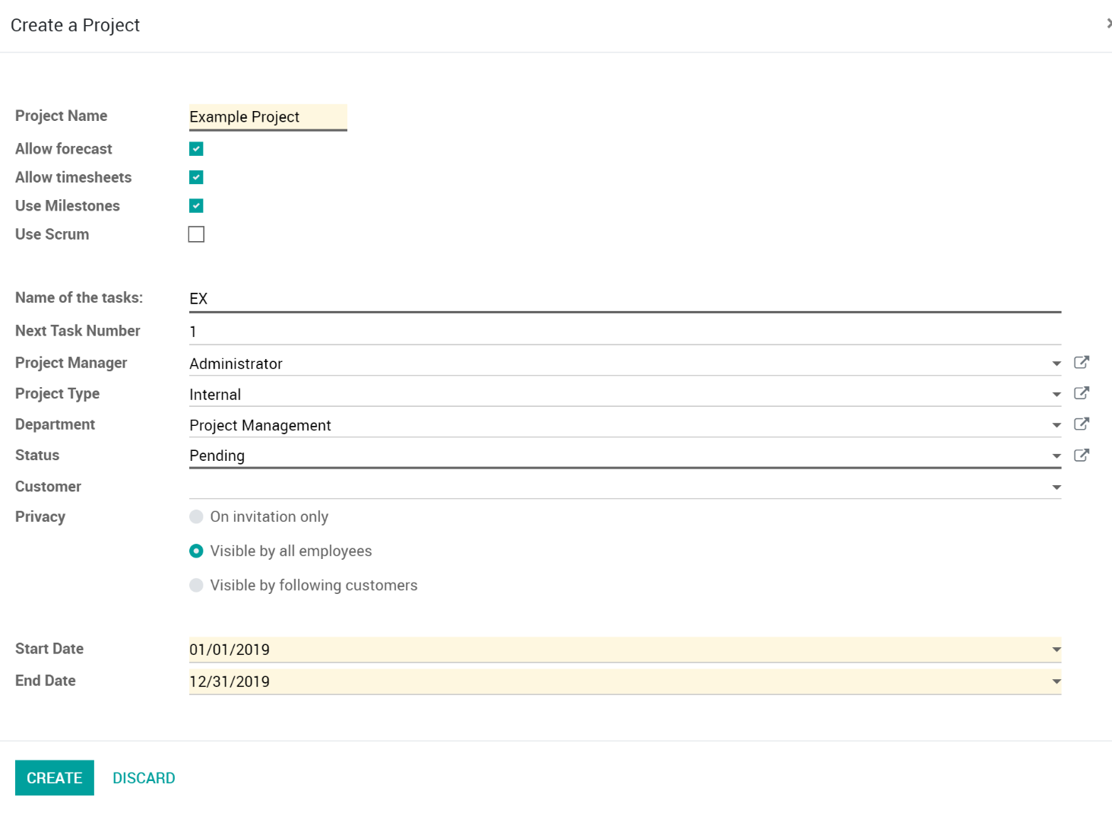

1. Field descriptions:
   1. **Project Name**: Specify the name of the Project.
   2. **Allow forecast**: Enables Forecasts for the Project.
   3. **Allow timesheets**: Enables Time Tracking for each Task on the Project.
   4. **Use Milestones**: Enables Milestones for the Project. See ‘Using Milestones’ for more information.
   5. **Use Scrum**: Enables Scrum for the Project. See ‘Using Scrum’ for more information.
   6. **Name of the Tasks**: Each Project will have its own Task labels that combine this field and the Next Task Number.
      1. For example, if you set this to PAV, and set the Next Task Number to 100, the next Task that will be created will have a Task Number of PAV-100 and will increment for each task created.
      2. Changing this later will change the labels of all Tasks associated with the Project.
   7. **Next Task Number**: Each Project tracks its own Task Numbers and you specify the next number here.
   8. **Project Manager**: The user who is managing the Project.
   9. **Project Type**: Specify the type the Project will be.
   10. **Department**: The Department that the Project is owned by.
   11. **Status**: The initial status for the Project.
   12. **Customer**: The customer that the Project is related to.
   13. **Privacy**: Who is given access to view/work the Project.
       1. **On invitation only**: Project is not visible to anyone unless they have been added as a follower.
       2. **Visible by all employees**: Project is only visible to employees and will see all tasks or issues.
       3. **Visible by following customers**: Project is visible by followers as well as following customers through Odoo’s customer portal, if the customer has been given the permissions to see their own portal pages.
   14. **Start Date:** The starting date of the Project.
   15. **End Date:** When the Project is set to be fully completed.
2. When you have entered all the required details, click on **Save**.

# Manage your project's stages

## Add your project's stages

1. After creating a new Project, it should take you directly to the Tasks.
2. In the new window, add a new column and name it according to the first stage of your project, then add as many columns as there are stages in your project.

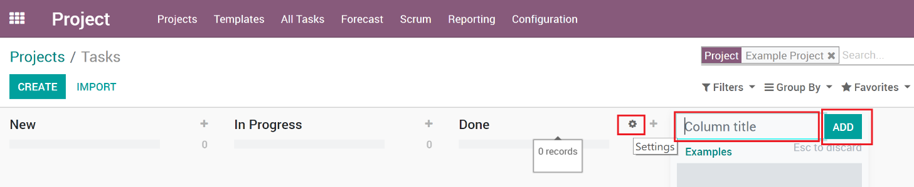

1. For each stage, there are markers for the status of tasks within a stage, that you can personalize to fit your needs.
2. Drag your mouse pointer over a stage name, and click on the appearing bearing, and on the opening menu, click on Edit Stage.

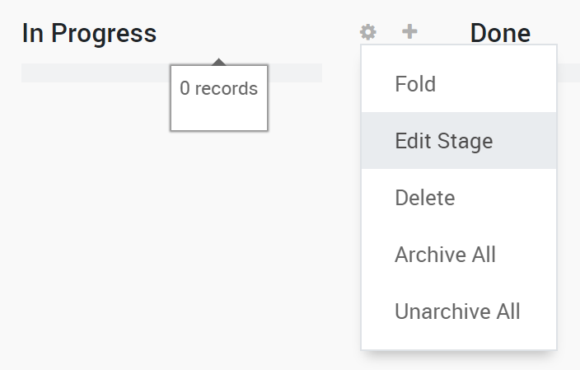

1. A new window will open. The color dots and star icon correspond to customizable markers applied on tasks, making it easier to know what task requires attention. You can give them any signification you like.

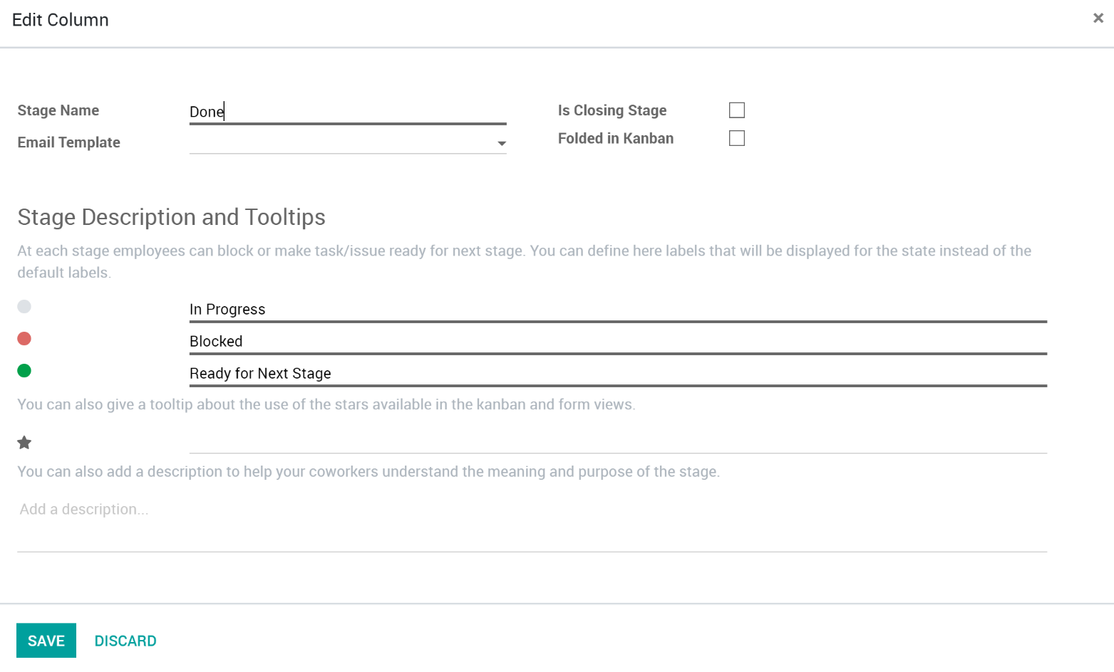

1. Click on **Save** when you are done.

## Rearrange stages

There are several different views available in Odoo and you can switch between views by looking for the view icons in the top right of any view that contains multiple items.

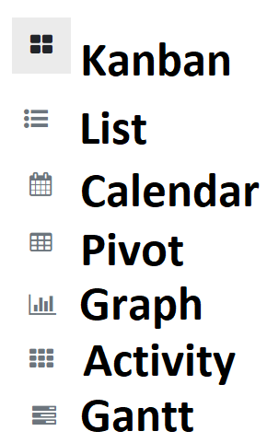

From the Kanban view of your project, you can add stages by clicking on Add new column. If you want to rearrange the order of your stages, you can easily do so by dragging and dropping the column you want to move to the desired location. You can also fold or unfold your stages by using the Setting icon on your desired stage.

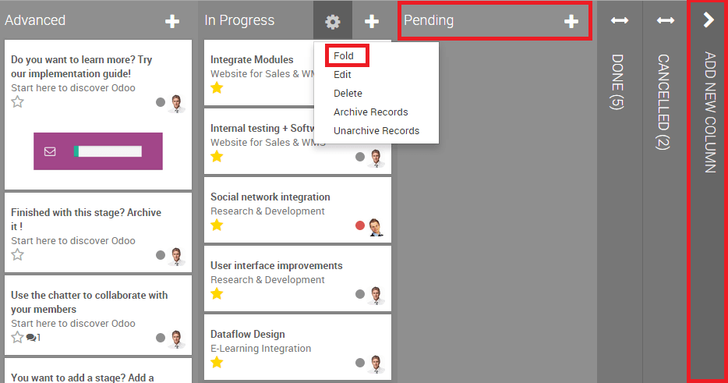

# Creating a Task

## Responsibilities

In Odoo, you can assign the person who oversees the task.

When creating a task, by default you are responsible for it. You can change this by simply typing the username of someone else and choosing it from the suggestions in the drop-down menu.

# Followers

In a project or task, you can add other users as Followers. Adding a follower means that this person will be notified of any changes that might happen in the task. The goal is to allow outside contribution from the chatter. This can be invaluable when you need the advice of colleagues from other departments. You could also invite customers to take part in the task. They'll be notified by email of the conversation in the chatter and will be able to take part in it simply by replying to the mail. The followers can see the whole task like you, with the description and the chatter.

## Project: follow a project throughout the process

You can decide to follow a Project. In this situation, you'll be notified of any changes from the project: tasks sliding from one stage to another, conversation taking place, etc. You'll receive all the information in your inbox. This feature is perfect for a Project Manager who wants to see the big picture all the time. Open the Project in edit mode to add/edit followers of the entire Project in the chatter box area.

## Task: follow a specific task

Following a task is the same idea as following a project, except you are focused on a specific part of the project. All notifications or changes in that task also appear in your inbox. Open the Project in edit mode to add/edit followers of the entire Project in the chatter box area.

## Choose which action to follow

You can choose what you want to follow by clicking on the down arrow in the Following button.

By default, you follow the discussions, but you can also choose to be notified when a note is logged in, when a task is created, blocked or ready to go, and when the stage of the task has changed.

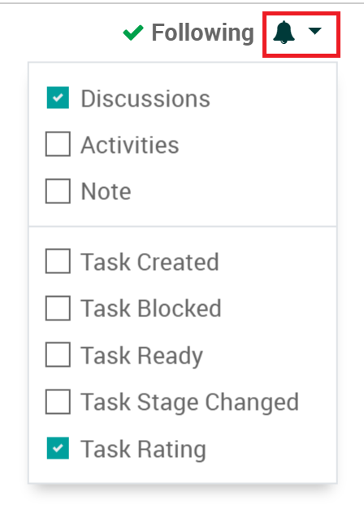

As a Project Manager, you can also specify what notifications each follower gets, click the followers drop down then hover over a follower, and you will see the pencil icon to edit what notifications they will get.

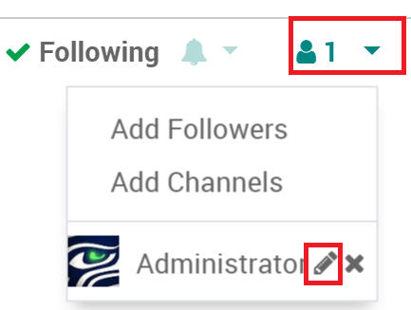

# Auto Forecasting

If Auto Forecasting is enabled for a Project, when a Task gets assigned, has planned hours and a start/end date, a Forecast record is automatically created. If any of those items change, the Forecast record is automatically updated. This helps ease the overhead it takes to manage forecasting.

## Enabling Auto Forecasting

Enabling Auto Forecasting is done on a per Project basis and ‘Allow Forecasting’ needs to be checked in order to see the option.

1. Open a Project in Edit mode.
2. Make sure ‘**Allow Forecasts**’ is checked.
3. Go to the **Settings** Tab.
4. Check the ‘**Allow Auto Forecasts**’.

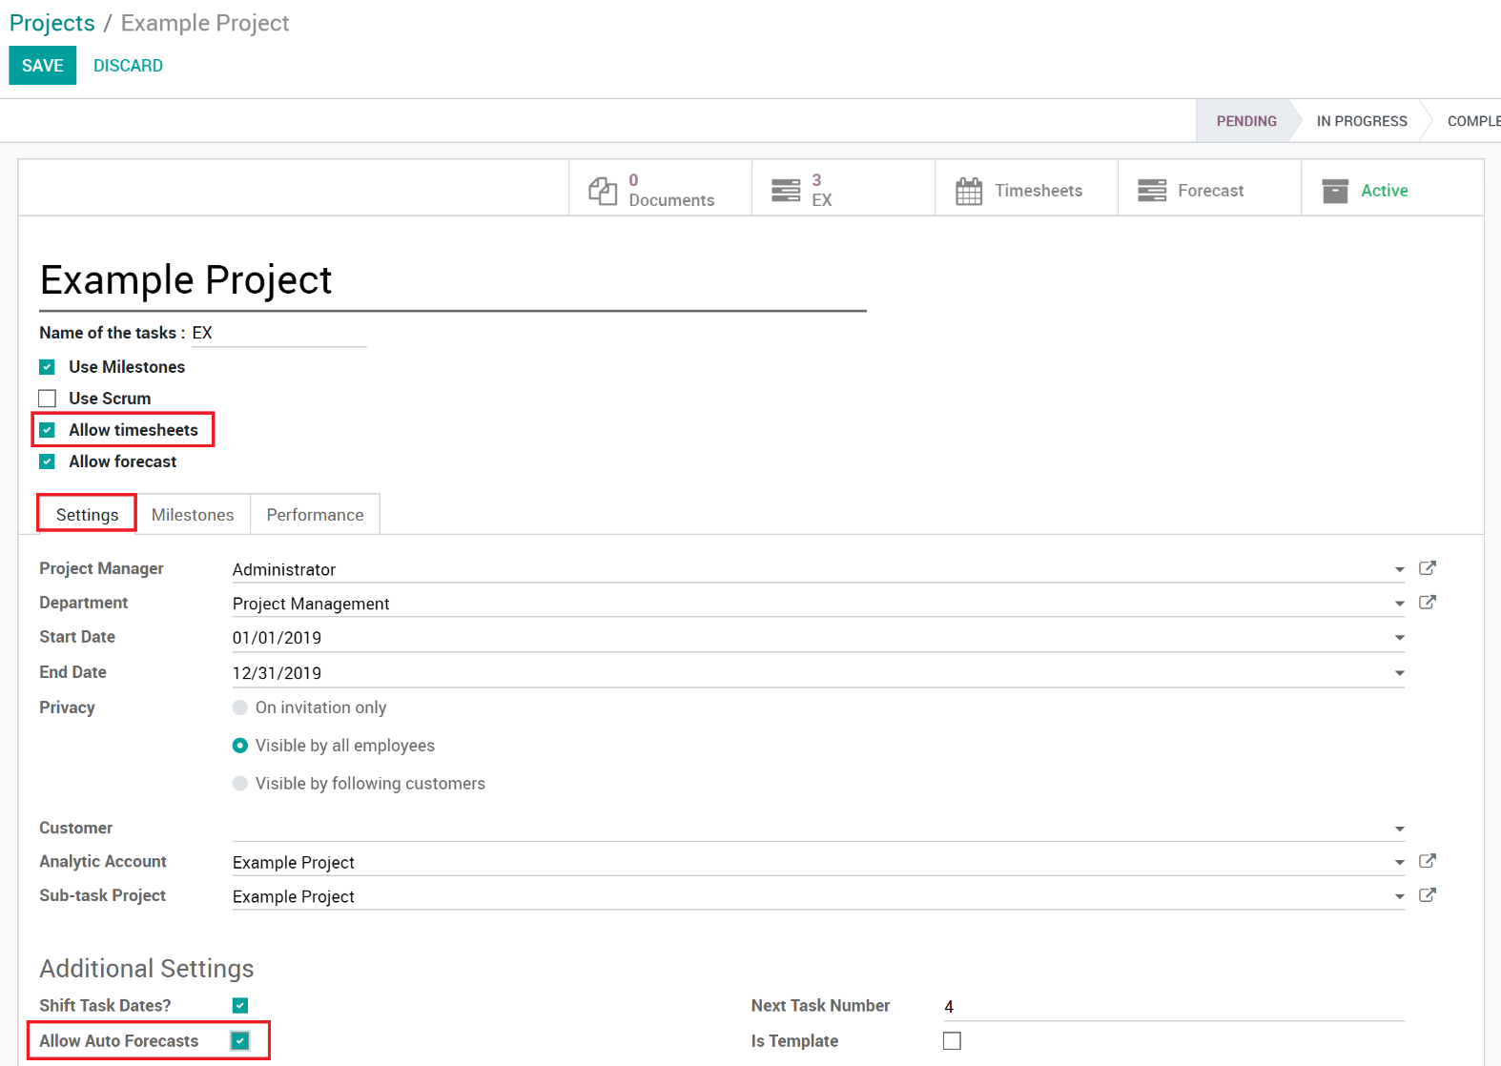

1. Click ‘**Save’** to save your Project.
2. Now when the relevant fields are filled in on a Task, a Forecast will be auto created.

## Viewing Forecasts

### Forecast Menu

You can view the Forecasts via the Forecast menu, then by selecting ‘By Employee’, ‘By Project’ or ‘By Sprint’.

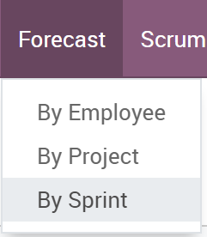

### On Projects

You can view all forecasts in the project itself if desired to do so.

1. Open the Project in edit mode.
2. In the Top Left, if Forecasts exist then you can click the ‘Forecast’ smart button. Note: The smart button will only show if there are already Forecasts created on Tasks, otherwise there won’t be a button.
3. 

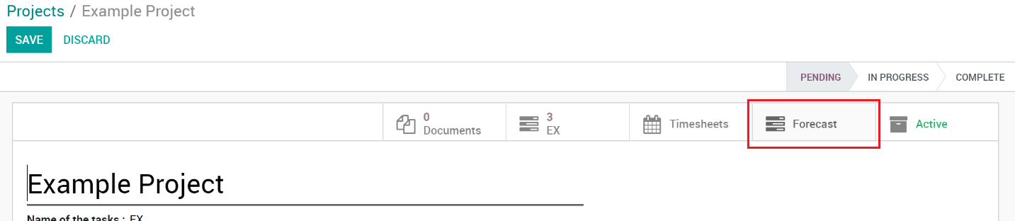

### On Tasks

1. Open the Task.
2. Go to the Forecasts Tab
3. All created Forecasts related to this Task will be listed. If auto create is enabled, then they will show as well as any manually created Forecasts.

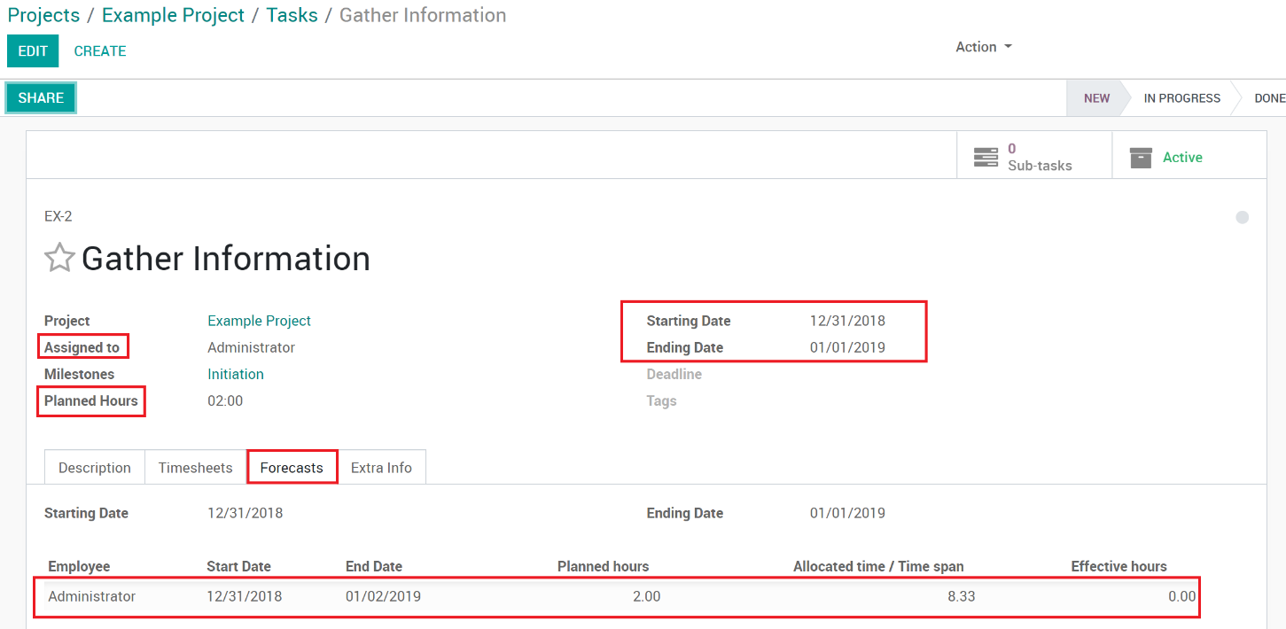

# Milestones

Milestones are used in project management to mark specific points along a project timeline. These points may signal anchors such as a project start and end date, a need for external review or input and budget checks, among others. In many instances, milestones do not impact project duration but allow for Task groupings by Milestones.

## Enabling Milestones on a Project

1. Open the Project in Edit mode.
2. Check the ‘**Use Milestones**’ checkbox.

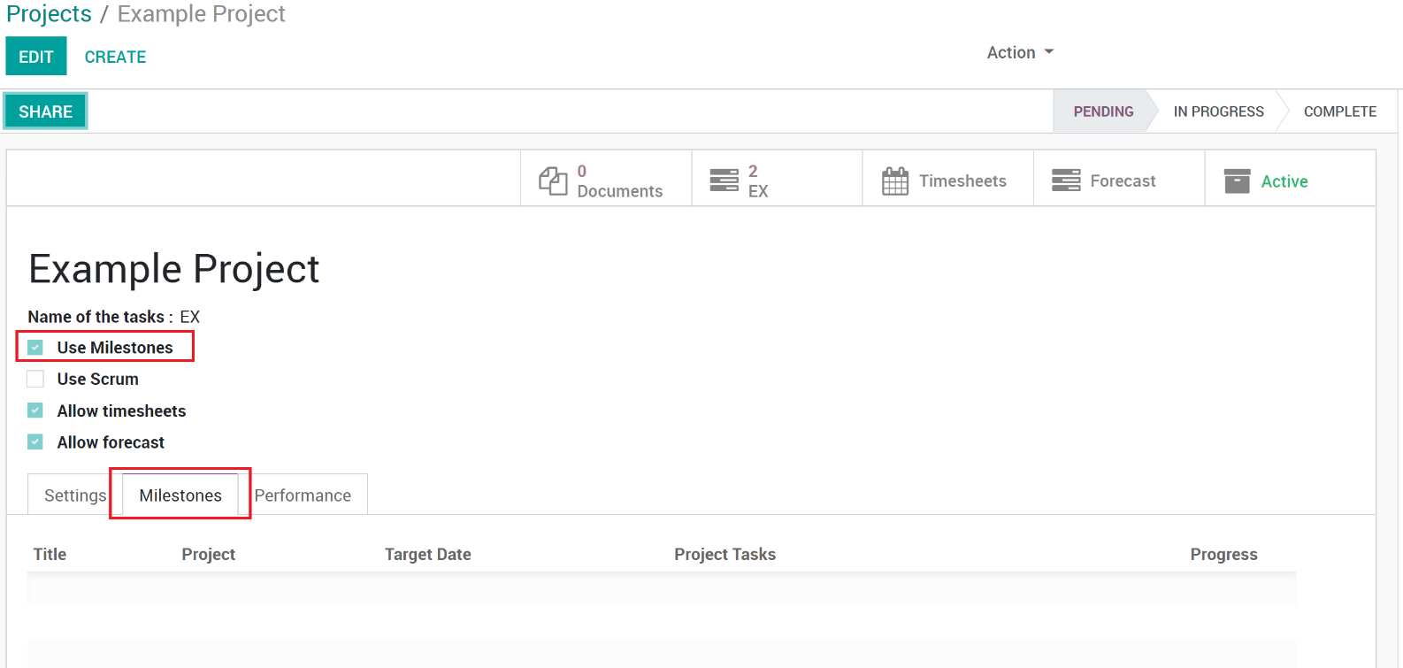

1. Once enabled, the Milestones tab will show where you can manage Milestones on the Project.

## Creating Milestones

1. Open the Project in Edit Mode.
2. Go to the Milestones tab.
3. Create a new Milestone by clicking the ‘Add a line’ link

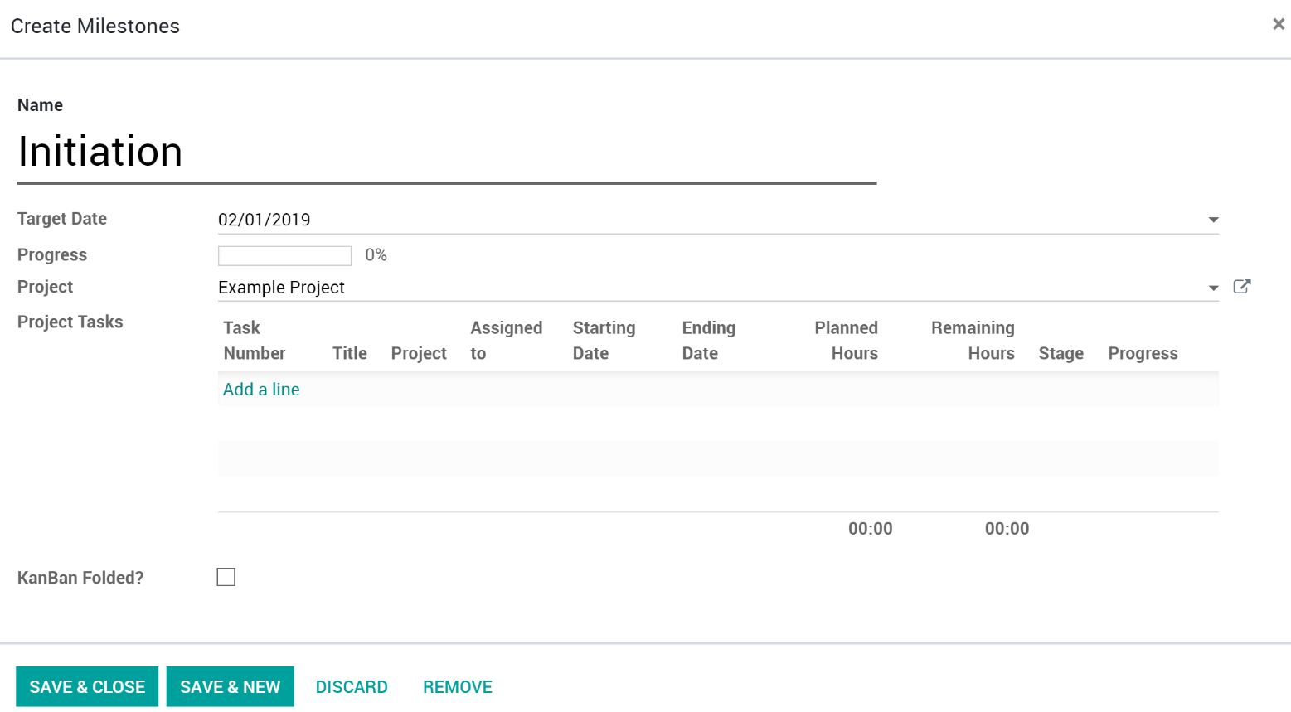

1. Field Descriptions:
   1. **Name**: Name of the Milestone.
   2. **Target Date**: Set the date that all the Tasks within the Milestone are expected to be completed, therefore the Milestone is expected to be completed.
   3. **Project**: Should auto fill with the current Project. Can be changed to another Project too.
   4. **Project Tasks**: List of Tasks that have been set to use this Milestone.
   5. **KanBan Folded?:** Because Milestones can be used to group by on the Task Kanban view, you can set the Milestone to be folded on that view.
2. Click ‘**Save & Close’** if you are done, or ‘**Save & New’** to create another.
3. Click ‘**Save’** on the Project to fully save the changes.
4. While in Edit Mode, you can rearrange the Milestones by drag and drop within the Milestone list. This can also be done while looking at the Tasks and grouping by Milestones. See ‘View by Milestones’
5. Now that Milestones are enabled and created on the Project, you can select them when creating your Tasks.

## View by Milestones

List: You can change the Task List view to group by Milestones. To do so…

1. Open the Tasks for the Project.
2. Switch to the Task List View.
3. Click the ‘Group By’ drop down then select ‘Milestones’.

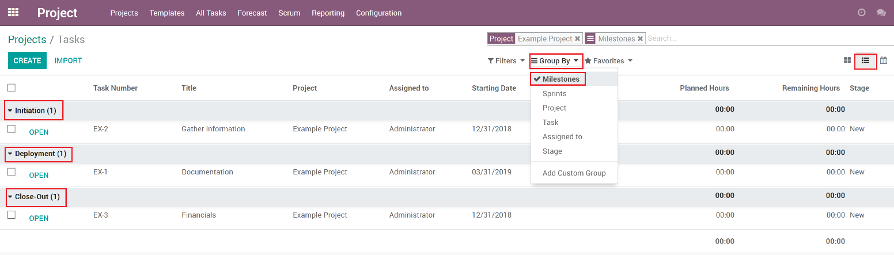

1. You can now see the Tasks listed underneath each Milestone.

Kanban: You can change the Task Kanban view to group by Milestones. To do so…

1. Open the Tasks for the Project.
2. Click the ‘Group By’ drop down then select ‘Milestones’.

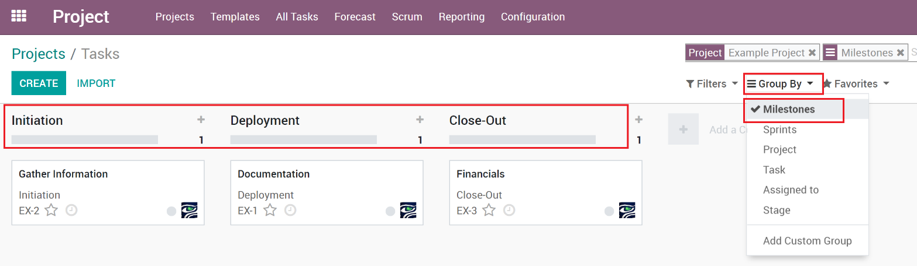

1. You can now see the Tasks listed underneath each Milestone.

# Templates

Templates allow frequently used Projects to be built as Templates, where Projects can be built from.

## Creating a Project Template

Templates are created the same way as a Project is but has a ‘Is Template’ check box to convert the Project to a Template.

1. Create a Project.
2. Open the Project in Edit mode
3. Check the ‘**Is Template**’ checkbox. When checked, the name will now show a (TEMPLATE) at the end.

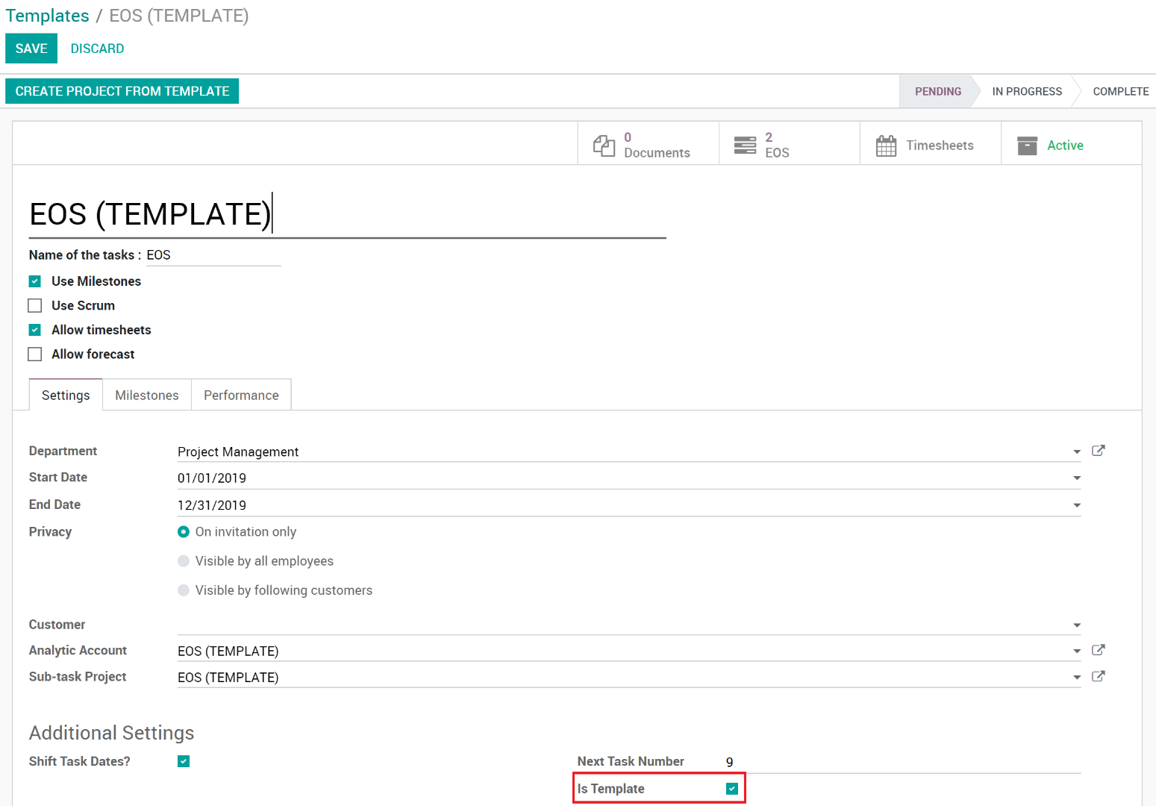

1. Click ‘**Save’** to save the Project.
2. The Project is now considered a Template and will now show in the Templates area and can be used by users to create Projects from.

## Create a new project (from Template)

1. Go to **Templates** in the menu.



1. Find the Template you want to create a Project from and click the ‘**Create Project From Template**’ button.

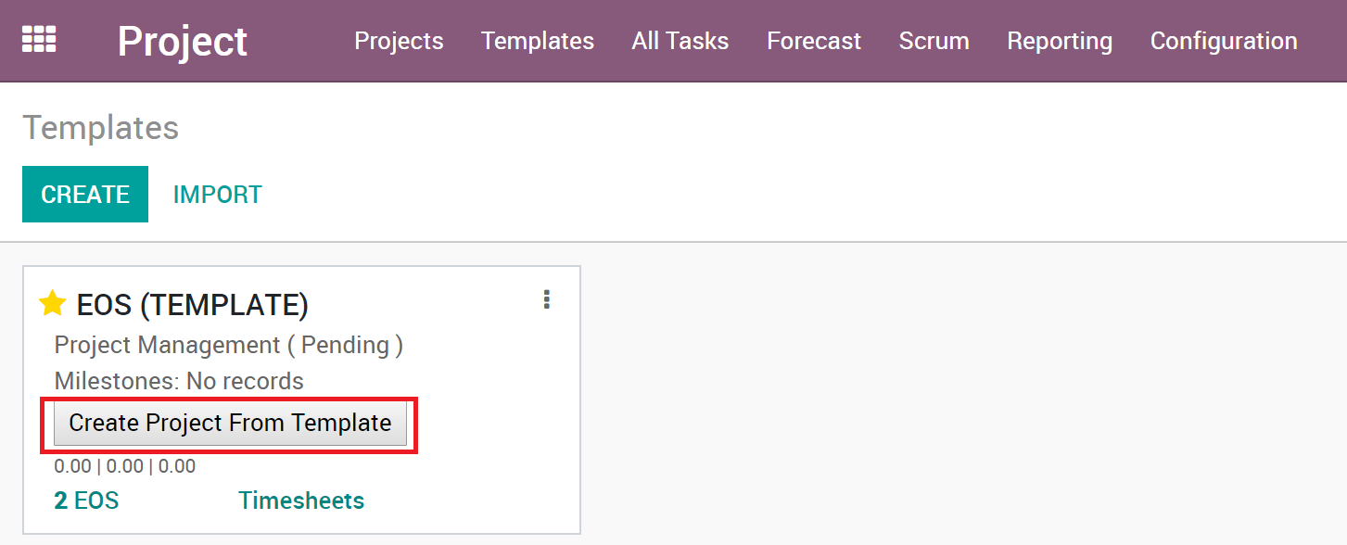

1. Your newly created Project will open, edit and change the information to match your needs.

# Date Shifting

Date shifting allows all the Task dates to be shifted when the Project’s start date changes. When enabled, when the project manager changes the start date of the Project, all the Tasks start/end dates will shift the number of days/months/years that the start date has changed. For example, if the start date of the Project was moved ahead one month, all the Tasks start/end dates would be moved ahead one month.

## Enabling Date Shifting

To enable Date Shifting on a Project…

1. Open the Project in edit mode.
2. Check the ‘**Shift Task Dates?**’ checkbox.

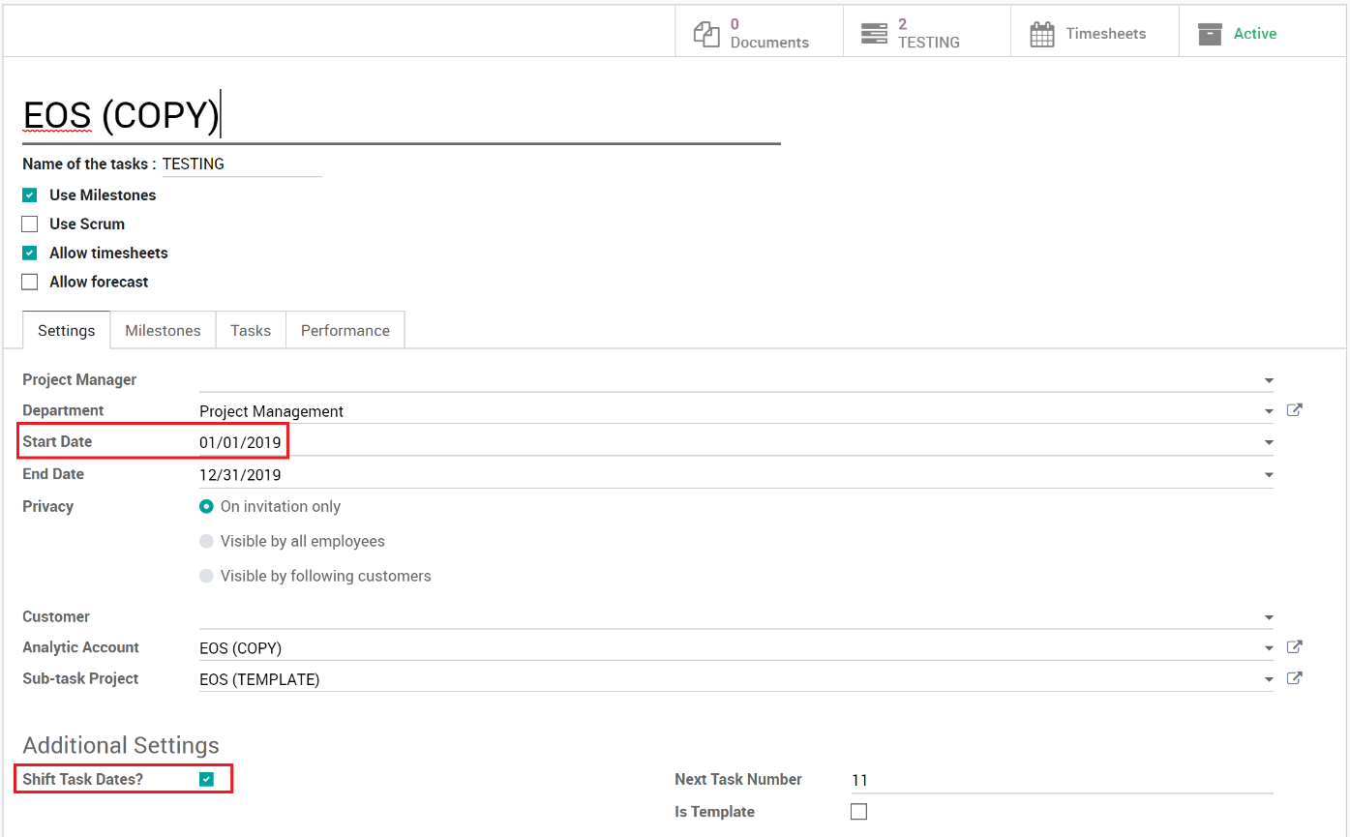

1. Now, whenever the **Start Date** changes, the Task Dates will shift accordingly.

# Scrum

The Scrum Project Enhancement enables a Project to use the Scrum framework and includes additional scrum related fields on Tasks and adds Epics, Sprints and Releases to Projects.

## Enabling Scrum

To enable Scrum for a Project…

1. Open the Project in edit mode.
2. Check the ‘Use Scrum’ checkbox.

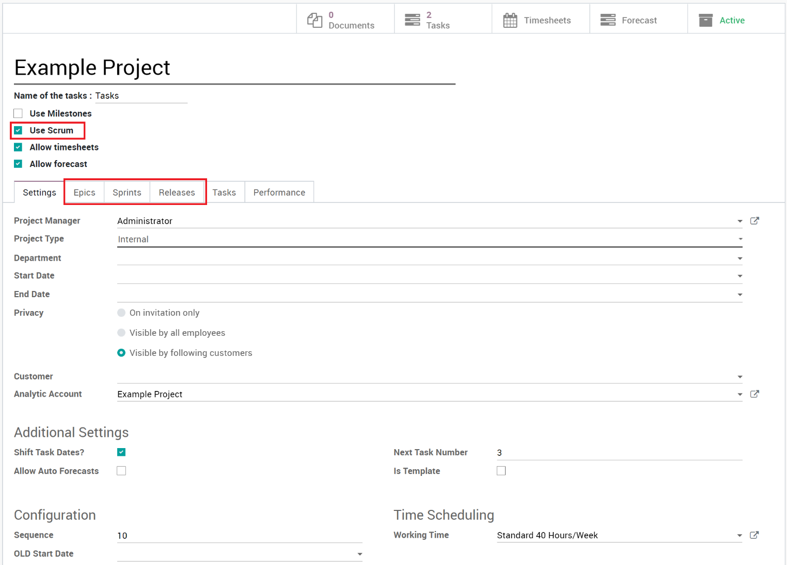

1. Now Epics, Sprints and Releases tabs show on the Project and Scrum related fields will be visible on tasks and the project and tasks can be added to Sprints and Releases.

## Configuration

There are multiple global Scrum configurations to be set in order to use Scrum on Projects. These settings can be found in the main Configuration menu.

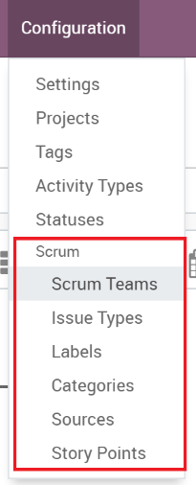

### Scrum Teams

Scrum Teams give the ability to group users into teams, to be used on Sprints.

1. Go to ‘**Configuration’** menu and click ‘**Scrum Teams**’.
2. Click ‘**Create’**.
3. Set the **Name** of the team and add **Team Members**.

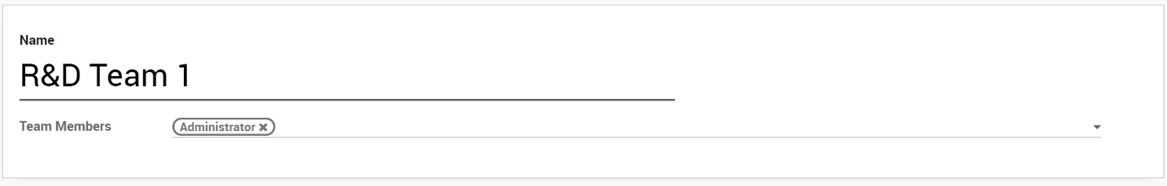

### Issue Types

Issue Types are used to specify the type of Task. Feature and Bug are added by default but can be changed. Issue Types are required on Tasks and can have an image associated with them that show on the Task and Kanban that allows users to visually see the issue types. To create an Issue Type…

1. Go to ‘**Configuration’** menu and click ‘**Issue Types**’.
2. Click ‘**Create’**.
3. This uses inline editing, enter **Name**, **Description** and choose an **Image**. Note: After saving, the image may not show at first, refresh the page and you will then see the image.

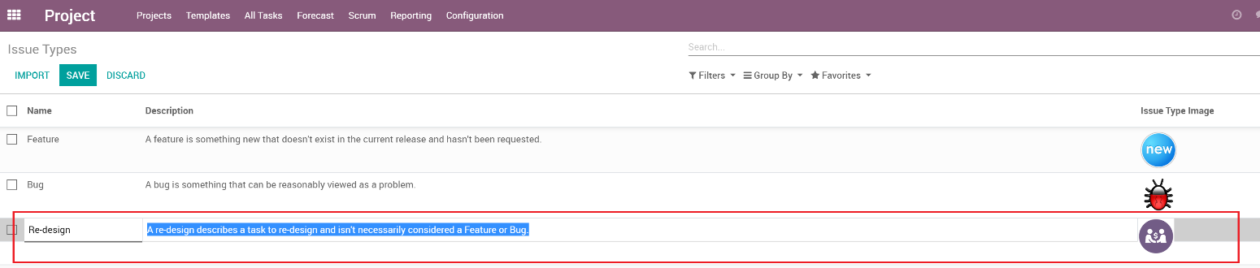

### Labels

Labels give yet another way to organize your Tasks. To create a Label…

1. Go to ‘**Configuration’** menu and click ‘**Labels**’.
2. Click ‘**Create’**.
3. This uses inline editing, enter **Name** and **Description**.

### Categories

Labels give yet another way to organize your Tasks by using Categories. To create a Category…

1. Go to ‘**Configuration’** menu and click ‘**Categories**’.
2. Click ‘**Create’**.
3. This uses inline editing, enter **Name** and **Description**.

### Sources

Sources are used to describe where the request came from. To create a Source…

1. Go to ‘**Configuration’** menu and click ‘**Sources**’.
2. Click ‘**Create’**.
3. This uses inline editing, enter **Name** and **Description**.

### Story Points

Story points are a unit of measure for expressing an estimate of the overall effort that will be required to fully implement a product backlog item or any other piece of work. When we estimate with story points, we assign a point value to each item. To create a Story Point…

1. Go to ‘**Configuration’** menu and click ‘**Sources**’.
2. Click ‘**Create’**.
3. This uses inline editing, enter **Name**, **Description** and **Value**. The Value is an integer, used to calculate total points during the Sprint process.

## Epics

An epic is a body of work that can be broken down into specific tasks (called “stories”, “tasks” or “user stories”) based on the needs/requests of customers or end users. Epics are another helpful way to organize your tasks into smaller groups.

When ‘Use Scrum’ is enabled on a Project, you can add Epics from the Project form.

1. Open the Project in Edit mode.
2. Go to the ‘**Epics**’ tab.
3. Click ‘**Add a line**’ to create an Epic or click an existing Epic to edit it.

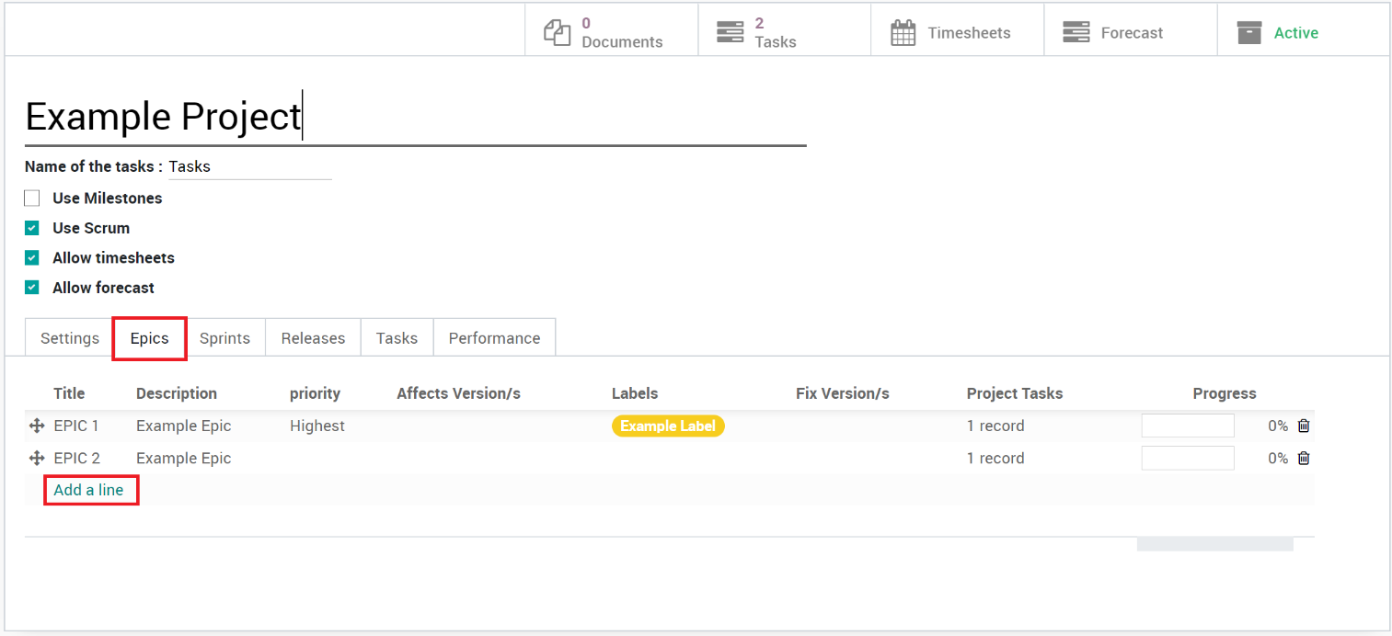

1. Fill in the fields, select the Tasks to be associated to the Epic and click ‘**save**’

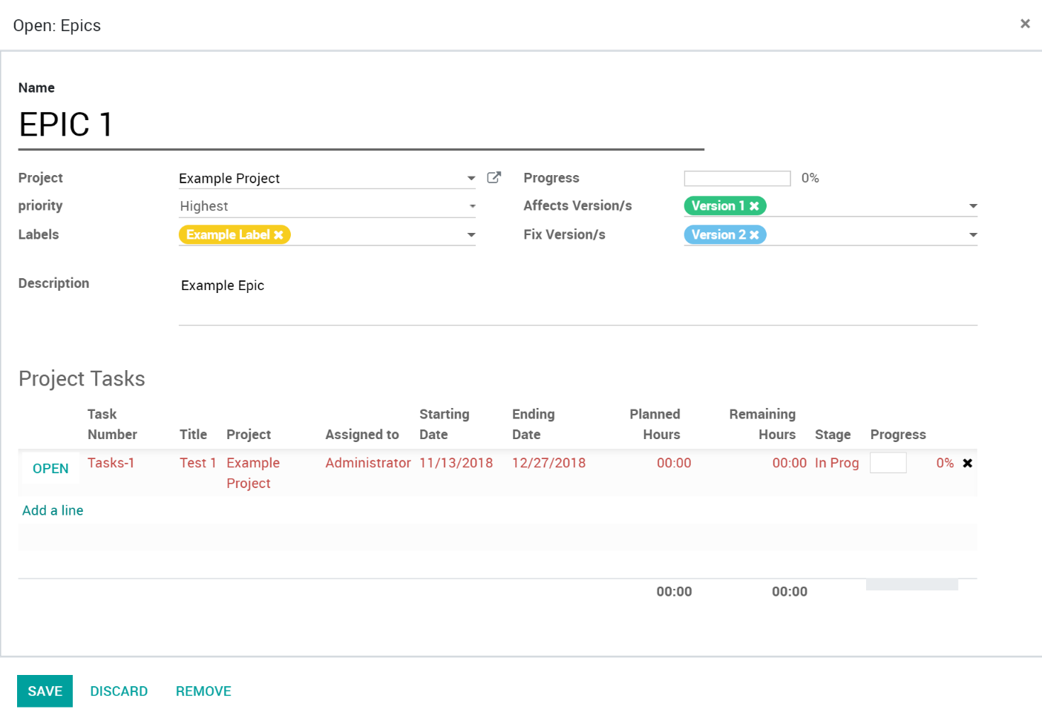

Field Descriptions:

* **Name:** The name of the Epic.
* **Project:** The Project the Epic is a part of.
* **Priority:** The priority of the Epic, includes: Lowest, Low, Medium, High, Highest.
* **Labels:** Same labels that are available on Tasks, to help organize Epics if needed.
* **Progress:** Percentage of completed Tasks that are related to the Epic vs total tasks.
* **Affects Version/s:** Version/s this Epic’s Tasks are affecting.
* **Fix Version/s:** Version/s this Epic’s are going to be resolved in.
* **Description:** Description of the Epic.
* **Project Tasks:** List of tasks set to be related to the Epic.

You can also view all Epics via the menu. Go to ‘**Scrum**’ then ‘**All Epics**’ to see the list of all Epics, grouped by Project.

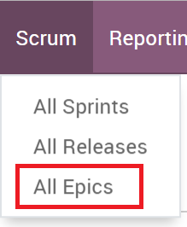

## Project Tasks (With Scrum)

When ‘Use Scrum’ is enabled on a Project, additional fields show on the Tasks and some become required. These are grouped in the body of the Task and are hidden if the Project isn’t using Scrum.

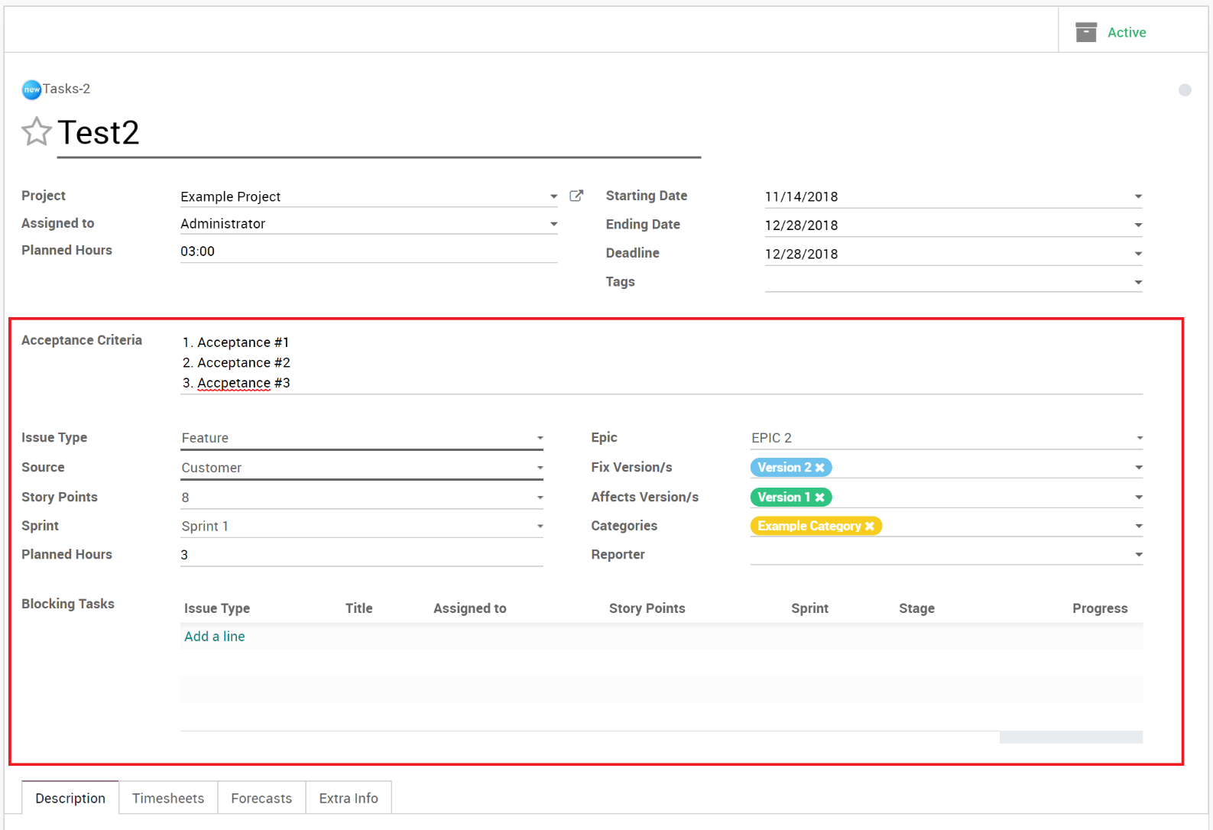

Field Descriptions:

* **Acceptance Criteria**: Acceptance criteria define what must be done to complete the Task.
* **Issue Type**: The type of issue, like Feature or Bug.
* **Source**: Where the task originated from. Customer, Internal, etc.
* **Story Points**: Pointing the task for the level of effort it will take to complete.
* **Sprint**: The Sprint that the Task is assigned to.
* **Planned Hours**: Estimated hours it will take to complete the Task.
* **Epic:** The Epic this task belongs to.
* **Fix Version/s**: The version or versions the Task is scheduled to be included in for release.
* **Affects Version/s**: The affected version or versions the issue was related to or discovered.
* **Categories**: Organizational options for grouping or organizing tasks.
* **Labels**: Like Categories, a way to group or organize tasks.
* **Reporter**: Who reported the Task. This could be a user, employee, vendor, customer, etc.
* **Blocking Tasks**: Tasks that need to be completed before this Task can be completed.

## Sprints

A sprint (or iteration) is the basic unit of development in Scrum. The sprint is a timeboxed effort; that is, it is restricted to a specific duration. A Sprint can have one or more Projects and Scrum Teams assigned. Tasks are listed, pointed, assigned and time estimates added. Forecasts can also be used to see user capacities and schedules. See ‘Auto Forecasts’ for more information.

To create a Sprint…

1. Go to ‘Scrum’ then ‘All Sprints’ in the main menu.

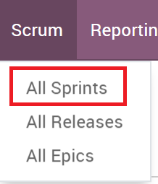

1. Click the ‘**Create’** button to create a new Sprint.

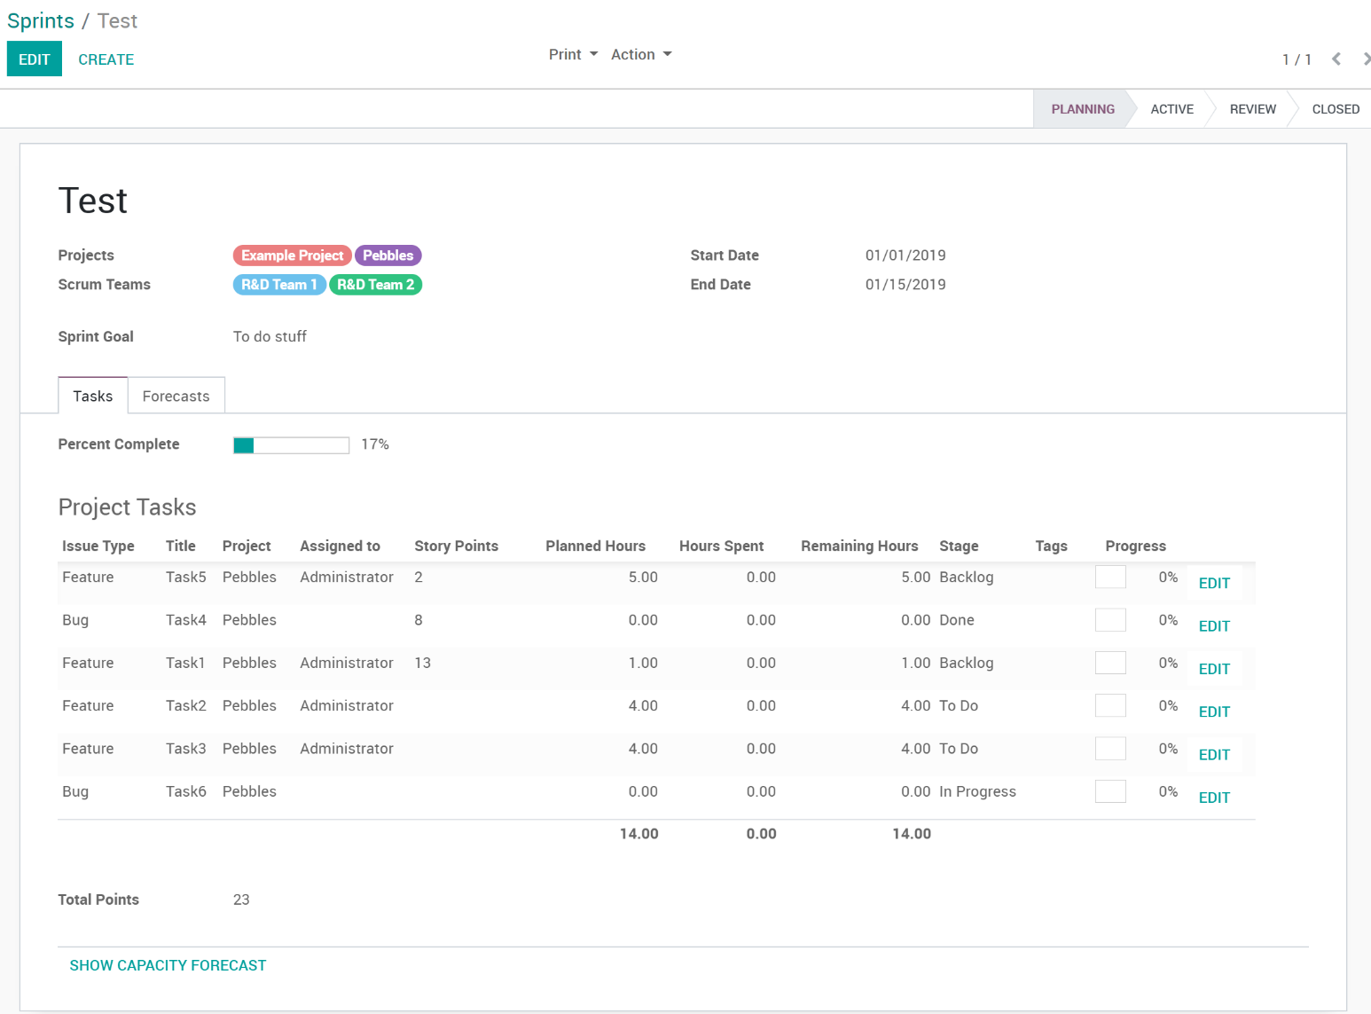

1. Field descriptions:
   1. **Name**: Enter the name for your Sprint. Note: An auto name will be created if a current Sprint is closed and a new one auto created. This can be changed if desired.
   2. **Projects**: List of Projects the Sprint is related to.
   3. **Scrum Teams**: List of Scrum Teams working this Sprint.
   4. **Start Date**: When the Sprint starts.
   5. **End Date**: When the Sprint ends.
   6. **Sprint Goal**: A simple description of the overall goal of this sprint.
   7. **Tasks**: List of Project Tasks being worked for this Sprint.
      1. **Percent Complete**: Percent of completed Tasks (Tasks in a ‘is closed’ stage) vs total Tasks.
      2. **Total Points**: Calculated field adding up all the Story Points on Tasks.
   8. **Forecasts**: Lists forecasts from all Tasks. If ‘Auto Forecasts’ is enabled on the Project, these should auto create when the Task has a start date, end date, assigned user and planned hours.
   9. **Show Capacity Forecast**: Opens the Forecast view for the Sprint.

## Activating/Closing Sprints

Starting and Closing Sprints is as easy as clicking buttons.

* **Start Sprint**: When a new Sprint is created, it is auto set to the ‘Planning’ stage. Click the ‘**Start Sprint**’ button to start the Sprint. The Sprint will become ‘**Active’**.
* **Review Sprint**: When a Sprint is active, you will see the ‘**Review Sprint**’ button. Pressing this button moves the Sprint to the ‘**Review**’ Stage.
* **Closing:** Once the Sprint is in the review stage, is can then be closed. There are two ways to close a Sprint.
  + **Close and New:** The ‘**Close and New**’ button will close the current Sprint and Create a new one. It will remove the uncompleted Tasks from the current Sprint and add them to the new Sprint. The new Sprint name will be “Sprint-id”, id will be the auto id assigned to the record. You can change the name if desired. The Projects and Scrum Teams will also be copied to the new Sprint but can be modified as needed.
  + **Close**: This button will just close the current Sprint and remove the incomplete tasks. A new Sprint will NOT be created.

## Releases

Releases allow you to organize, track and manage releases. Tasks can be added to releases and when released, notifications can be auto sent (if setup to do so) and release notes auto generated from the related tasks.

To create a Release…

1. Go to ‘**Scrum**’ then ‘**All Sprints**’ in the main menu.

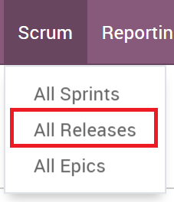

1. Click the ‘**Create’** button to create a new Release.

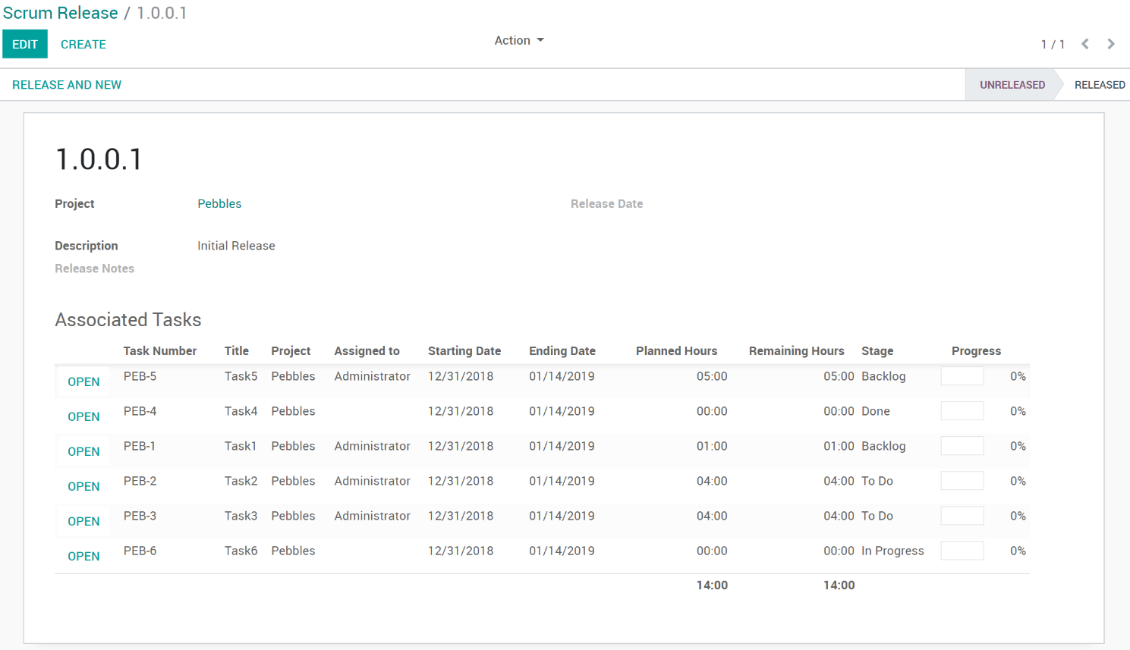

1. Field Definitions:
   1. **Project**: The Project the release is linked to.
   2. **Description:** A quick description of the Release.
   3. **Release Notes:** Release notes for this release. Is auto generated from the Task Numbers and Names. If text exists in the field prior to release, the auto information is amended to the existing text.
   4. **Associated Tasks:** List of Tasks set to be in the release.

## Releasing

Once a Release is deployed, it should be set to ‘Released’ status. To do so, simply click the ‘**Release and New**’ button. This will do the following:

* Auto populate the release notes.
* Create a new release
* Move any incomplete Tasks to the new release.
* Move the current release to ‘Released’ status.

If desired, an automated action can be setup to send an email to users with the release notes information. This would be setup manually and isn’t included in the Projects Enhancements module yet.